**“Jnana Sangama”** **, Belagavi-590018, Karnataka**

**VISVESVARAYA TECHNOLOGICAL UNIVERSITY**



### Phase I Project Work Report

**On**

### “DEEP LEARNING FOR MEDIA AUTHENTICATION AND FAKE CONTENT DETECTION”

**Submitted in partial fulfillment of the requirements for the award of the degree of Bachelor of Engineering**

**in**

**Computer Science & Engineering**

#### Submitted by

**USN Name**

**1BI22CS136 S ASHWIN REDDY**

**1BI22CS166 SUDEEP PATIL**

**1BI22CS174 THUSHAR DM**

**1BI22CS190 VINAYAK RAJPUT**

Under the Guidance of

#### Prof. NIKITHA GOWDA K. S.

Assistant Professor Department of CS&E, BIT Bengaluru-560004



**Department of Computer Science & Engineering**

### BANGALORE INSTITUTE OF TECHNOLOGY

K.R. Road, V.V. Pura, Bengaluru-560 004

#### 2024-25

**“Jnana Sangama”,** Belagavi-590018, Karnataka

**VISVESVARAYA TECHNOLOGICAL UNIVERSITY**

**BANGALORE INSTITUTE OF TECHNOLOGY**

Bengaluru-560 004



**Department of Computer Science And Engineering**

***Certificate***

This is to certify that the Mini Project (BCS586) work entitled **“DEEP LEARNING FOR MEDIA AUTHENTICATION AND FAKE CONTENT DETECTION”** carried out by

|  |  |
| --- | --- |
| **USN** | **Name** |
| **1BI22CS136** | **S ASHWIN REDDY** |
| **1BI22CS166** | **SUDEEP PATIL** |
| **1BI22CS174** | **THUSHAR DM** |
| **1BI22CS190** | **VINAYAK RAJPUT** |

bonafide students of VI semester B.E. for the partial fulfillment of the requirements for the Bachelor's Degree in Computer Science & Engineering of the **VISVESVARAYA TECHNOLOGICAL UNIVERSITY** during the academic year 2024-25. It is certified that all corrections/suggestions indicated for Internal Assessment have been incorporated in the report deposited in the departmental library. The project report has been approved as it satisfies the academic requirements in respect of Project work prescribed for the said degree.

|  |  |
| --- | --- |
| **Prof. Nikitha Gowda K. S.**  Internal Guide Assistant Professor Dept. of CSE, BIT | **Dr. Suneetha K. R.**  Prof. & Head, Dept. of CSE, BIT |

## ACKNOWLEDGEMENT

The knowledge & satisfaction that accompany the successful completion of any task would be incomplete without mention of people who made it possible, whose guidance and encouragement crowned our effort with success. We would like to thank all and acknowledge the help we have received to carry out this project.

We would like to convey our thanks to Principal **Dr. Aswath M U,** Bangalore Institute of Technology, and **Dr. Suneetha K R,** Professor and Head, Department of Computer Science and Engineering, BIT for being kind enough to provide the necessary support to carry out the Mini Project.

We would like to acknowledge the support we have received from the Major Project coordinators **Prof. Prashanth Kumar K N,** Asst. Prof. and **Prof. Manjushree N S,** Asst. Prof., Department of Computer Science and Engineering, BIT for continuous co-ordination and timely deliberation of requirements at every phase of the Major Project.

We are most humbled to mention the enthusiastic influence provided by our guide **Prof. Nikitha Gowda K S,** Assistant Professor on the Mini Project for the ideas, time to time suggestions, for the constant support and co-operation shown during the venture and for making this Major Project a great success.

We are very much pleased to express our sincere gratitude to the friendly co- operation shown by all the staff members of the Computer Science Department, Bangalore Institute of Technology.

**Names of the students S Ashwin Reddy Sudeep Patil Thushar D M Vinayak Rajput**

## ABSTRACT

In the digital age, the proliferation of manipulated media—ranging from subtly altered images to highly convincing deepfake videos—poses significant threats to privacy, security, journalism, and public trust. Traditional forensic methods often fall short in detecting increasingly sophisticated forgeries. This has spurred growing interest in leveraging deep learning techniques for media authentication and fake content detection. This paper explores the application of deep neural networks, particularly convolutional neural networks (CNNs) and recurrent neural networks (RNNs), in identifying synthetic and tampered media. We examine architectures such as autoencoders, generative adversarial networks (GANs), and transformers, which are instrumental both in creating and detecting fake content. Key challenges include dataset limitations, generalization to unseen manipulation methods, and real-time detection. We also discuss benchmark datasets, such as FaceForensics++ and DeepFake Detection Challenge (DFDC), and evaluate model performance using metrics like accuracy, precision, recall, and AUC. Ultimately, this study underscores the potential of deep learning to act as a critical defense against digital misinformation, while also highlighting the need for robust, interpretable, and ethically guided AI solutions.

**TABLE OF CONTENTS**

**Page no.**

CHAPTER 1: INTRODUCTION 1 - 6

* 1. Overview 2
  2. Purpose, Scope, and Applicability 3 - 6
     1. Purpose 3
     2. Scope 3
     3. Applicability 4
  3. Organization of Report 5 - 6

CHAPTER 2: LITERATURE SURVEY 7 - 14

* 1. Introduction 7
  2. Summary of papers 8 - 13
  3. Existing System 13
  4. Problem Statement 13
  5. Objectives 14

CHAPTER 3: REQUIREMENT ENGINEERING 15 - 21

* 1. Software and Hardware Requirements 16 - 18
  2. Conceptual/Analysis Modeling 18 - 21
  3. Software Requirements Engineering 21

CHAPTER 4: PROJECT PLANNING 22 - 24

CHAPTER 5: APPLICATIONS AND CONCLUSION 25 - 27

* 1. Applications 26
  2. Conclusion 27

REFERENCES 28 - 29

**LIST OF FIGURES**

|  |  |  |
| --- | --- | --- |
| **Figure No.** | **Figure Name** | **Page No.** |
| 3.1 | Use Case Diagram | 18 |
| 3.2 | Sequence Diagram | 19 |
| 3.3 | Activity Diagram | 19 |
| 3.4 | State Diagram | 20 |
| 3.5 | Class Diagram | 20 |
| 4.1 | Project Planning | 23 |

# Chapter 1 Introduction

### Chapter 1

### Overview

## INTRODUCTION

The rise of manipulated digital media has emerged as a pressing challenge in the modern information landscape. With the advent of powerful generative technologies, particularly Generative Adversarial Networks (GANs), it has become increasingly easy to create fake images and videos that are visually indistinguishable from real ones. These synthetic media, commonly referred to as deepfakes, can be used for entertainment or benign purposes, but they also pose serious threats when leveraged to spread misinformation, manipulate public opinion, or commit fraud. As these threats evolve, there is a growing demand for robust and reliable methods to authenticate media and detect forgeries.

Deep learning has proven to be one of the most effective tools in this domain due to its ability to learn complex visual and temporal patterns. Convolutional Neural Networks (CNNs) are widely used in image-based fake content detection, capable of identifying subtle anomalies in texture, lighting, and structure that may result from tampering. For video analysis, more complex architectures like recurrent neural networks (RNNs) and transformers are employed to capture temporal inconsistencies such as unnatural facial movements or mismatched audio-visual synchronization. These models are trained on large datasets of both real and fake media, such as FaceForensics++ and the DeepFake Detection Challenge (DFDC), to learn discriminative features that can separate authentic content from manipulated counterparts.

Despite significant progress, media authentication using deep learning still faces considerable challenges. One major issue is the generalization of detection models to novel or previously unseen manipulation techniques. As generative models continue to improve, detection systems must be regularly updated and retrained to stay effective. Another concern lies in real-time detection capabilities, which are essential for applications in content moderation and surveillance but require high computational efficiency. Moreover, the black-box nature of many deep learning models raises concerns about interpretability and trustworthiness, especially in high-stakes environments like legal or journalistic investigations.

In response to these challenges, researchers are increasingly focusing on hybrid models, explainable AI techniques, and the development of standardized benchmarks to evaluate performance. There is also a growing recognition of the need for ethical frameworks to govern the deployment of detection technologies, balancing the fight against false and other

concerns around privacy and surveillance. Overall, deep learning stands at the forefront of the battle against synthetic media, offering powerful tools to defend the integrity of visual information in an era of increasing digital deception.

### Purpose, Scope and Applicability

#### Purpose

The primary purpose of employing deep learning for media authentication and fake content detection is to safeguard the integrity and credibility of digital information in an era where manipulated media can be generated and distributed with unprecedented ease. As synthetic images and videos become more convincing due to advances in generative models like GANs, traditional manual or rule-based detection methods are no longer sufficient. Deep learning offers a scalable, data-driven approach to automatically identify forgeries, detect subtle inconsistencies, and differentiate between authentic and fabricated content with high accuracy. This technological capability serves multiple critical goals.

In journalism and media, it helps ensure that published visual content is trustworthy, reducing the spread of misinformation. In legal and forensic contexts, it aids in verifying the authenticity of digital evidence. For social media platforms and technology companies, it provides automated tools to moderate content and prevent the viral spread of harmful deepfakes. On a broader level, the purpose is also societal: to protect public discourse, democratic processes, and individual reputations from the disruptive potential of fake media. Ultimately, the use of deep learning in this context aims to create a more secure and transparent digital environment, where people can have greater confidence in the authenticity of what they see and share online.

#### Scope

The scope of deep learning for media authentication and fake content detection is broad and rapidly expanding, reflecting the growing complexity and scale of digital media manipulation. This field encompasses a wide range of applications, methodologies, and research directions, all aimed at detecting and mitigating the impact of fake images and videos. At its core, the scope includes the detection of various forms of image and video manipulations. These manipulations may involve deepfakes, face swapping, facial expression synthesis, image splicing, copy-move forgeries, and other subtle alterations designed to deceive viewers. Deep learning models are developed to identify such modifications by analyzing pixel-level anomalies, inconsistencies in lighting and shadows, or irregularities in motion and

expression dynamics across video frames.

In terms of technical scope, the field covers the design and training of deep neural network architectures such as CNNs, RNNs, autoencoders, transformers, and hybrid models tailored to visual data analysis. It also includes the use of adversarial training, multi-modal learning (combining visual and audio cues), and domain adaptation techniques to enhance model robustness and generalization. Researchers are exploring explainable AI approaches to increase transparency and trust in model decisions, especially in sensitive applications like law enforcement or journalism. The scope further extends to the development and curation of large-scale benchmark datasets, which are essential for training and evaluating detection systems.

Datasets such as FaceForensics++, Celeb-DF, and DFDC provide diverse examples of real and fake content that help models learn to generalize across different manipulation styles and levels of quality. On the application side, the technology finds use in social media monitoring, content verification for news organizations, digital forensics, cybersecurity, and even policy development related to media ethics and regulation. The increasing sophistication of generative models means that the scope of detection efforts must also include proactive strategies— such as real-time detection, watermarking, and tamper-proofing media content—to stay ahead of emerging threats. In summary, the scope of deep learning in media authentication spans fundamental research, applied technology, and societal impact. It addresses the urgent need for reliable solutions to protect against the dangers of digital deception in a hyperconnected world.

#### Applicability

The applicability of deep learning for media authentication and fake content detection spans numerous domains and real-world scenarios, reflecting the urgent need to combat digital deception in today's media-rich environment. As fake images and videos become more prevalent and sophisticated, deep learning offers powerful tools that can be integrated into various sectors to enhance security, trust, and information integrity. In the realm of digital journalism and media, deep learning models are used to verify the authenticity of user-generated content and visual material shared on social platforms before it is disseminated to the public. This helps media outlets prevent the spread of misinformation and maintain journalistic integrity. Automated detection systems can scan videos and images in real time to

flag suspicious content for further human review, greatly improving the speed and reliability of fact-checking processes.

Law enforcement and forensic investigations represent another critical area of applicability. Deep learning techniques assist forensic experts in determining whether visual evidence has been tampered with, which is essential in criminal investigations, court proceedings, and cybersecurity forensics. By identifying even minute manipulations, these models help ensure the credibility of digital evidence presented in legal contexts. In social media and content moderation, platforms such as Facebook, Twitter, and YouTube are increasingly incorporating deepfake detection algorithms into their systems to identify and limit the spread of harmful or misleading videos. These models can automatically screen content at scale, alerting moderators or applying restrictions when synthetic media is detected, thus helping to safeguard public discourse.

Entertainment and content creation industries also benefit from these technologies, particularly in the ethical use of synthetic media. Deep learning tools can be used to certify the authenticity of media products or watermark AI-generated content, ensuring transparency in production and consumption. This is especially relevant in areas like film, advertising, and influencer marketing, where digital manipulation is common but must be disclosed responsibly. Additionally, education and awareness campaigns leverage fake content detection tools to demonstrate the risks of manipulated media and train people to critically evaluate digital information. These applications are essential in building media literacy and promoting informed engagement among the general public. Overall, the applicability of deep learning in this field is both wide-ranging and impactful, offering scalable, intelligent solutions across industries to counteract the growing threat of synthetic media and reinforce digital authenticity in a rapidly evolving technological landscape.

### Organization of Report

The report begins with an Overview that introduces the project, its purpose, scope, and applicability. This section establishes the significance of the project and the real-world problems it seeks to address. It also covers the Existing Systems to identify gaps and provides the Problem Statement that the project aims to solve. The Objectives of the project are then outlined, followed by an Organization of the Report to guide the reader through the structure. Next, the Tools and Technologies section details the technologies and machine learning techniques used throughout the project, including the NLP tools and

platforms that facilitate the system's operations. This is followed by the System Design section, which describes the system's architecture, outlining the core components. The section also discusses the Algorithms and Methodology employed to analyze text and detect emotions. The Implementation section elaborates on the different approaches taken to develop the system, discussing the coding process, design decisions, and any challenges faced during development. It also includes the Source Code that powers the system’s functionality. Following the implementation, the Results section analyzes the performance of the system, evaluating its accuracy and effectiveness through testing. It also includes Snapshots to illustrate the outcomes or interface of the system in action. The Applications & Conclusion section explores the practical uses of the system in various domains, such as social media monitoring and mental health, and provides conclusions drawn from the project. The Future Scope of the Work is also discussed, identifying areas for improvement and expansion. Finally, the References section lists all the research materials, tools, and sources referenced throughout.

# Chapter 2 LITERATURE SURVEY

### Chapter 2

* 1. **Introduction**

## LITERATURE SURVEY

The section also discusses the Algorithms and Methodology employed to analyze text The rapid advancements in artificial intelligence and deep learning have led to significant breakthroughs in multimedia content generation. One of the most notable—and concerning—developments is the emergence of *deepfakes*, which involve the creation of highly realistic but entirely synthetic audio, video, or image content. These manipulated media artifacts are generated using techniques such as Generative Adversarial Networks (GANs), autoencoders, and facial reenactment technologies. While deepfake technology offers innovative possibilities in entertainment, education, and accessibility, its misuse poses serious ethical, legal, and social threats, including misinformation, political manipulation, and identity theft.

In response to these challenges, the research community has turned its focus toward developing reliable detection mechanisms. A wide range of machine learning (ML) and deep learning (DL) models have been proposed to address the issue of deepfake detection. Convolutional Neural Networks (CNNs), Recurrent Neural Networks (RNNs), Vision Transformers (ViTs), and hybrid models have been used to identify subtle inconsistencies in facial expressions, blinking patterns, skin texture, and temporal frame transitions. Additionally, researchers have investigated the use of handcrafted features, frequency domain analysis, and ensemble learning approaches to improve detection accuracy and robustness.

This literature survey aims to provide a comprehensive overview of recent advancements in the domain of deepfake detection. It explores a wide array of studies, highlighting the methods, datasets, evaluation metrics, and challenges addressed by each. By analyzing the strengths and limitations of existing approaches, this survey not only outlines the current state of the art but also identifies gaps that require further investigation, such as cross-dataset generalization, adversarial robustness, and real-time deployment feasibility. This foundational understanding is crucial for guiding future research toward more trustworthy and scalable detection systems.

### Summary of Papers

**Njood AlShariah et al. [1]** explored the detection of fake images specifically on Instagram using various machine learning and deep learning models such as CNNs, VGG variants, and ResNet. The study utilized feature extraction techniques including noise

patterns and color inconsistencies to identify tampered content. The model achieved an accuracy of 97% on a custom Instagram dataset. The paper highlights the effectiveness of deep learning models in social media contexts and demonstrates the feasibility of lightweight architectures.

**Methodology:** The researchers used a combination of handcrafted feature extraction techniques (such as color inconsistency analysis and noise detection) and deep learning classifiers. Multiple models, including VGG variants and ResNet, were trained on a dataset curated from real Instagram posts to mimic platform-specific tampering artifacts like filters and compression.

**Contributions:** This work shows that lightweight deep learning models can be effective in fake image detection on social media. It brings attention to platform-specific forgery traits and validates the use of tailored datasets for context-aware detection. The model’s high accuracy demonstrates the strength of combining deep features with platform-centric preprocessing.

**Drawbacks:** The scope is limited to Instagram, restricting generalizability to other platforms. The dataset is not benchmarked against public standards, reducing reproducibility. Additionally, the study does not evaluate robustness against adversarial attacks or test the model’s performance on high-resolution or cross-platform images.

**Md. Shohel Rana et al. [2]** conducted a comprehensive review of deepfake detection techniques using machine learning, deep learning, and hybrid approaches. The study provided a detailed comparison of detection strategies, model architectures, and datasets like FaceForensics++, Celeb-DF, and DFDC.

**Methodology:** This systematic review compiled and compared prior research studies without introducing any new experimental work. It structured existing literature into categories based on technique type, dataset usage, and detection accuracy, offering theoretical insights into common practices and challenges.

**Contributions:** The paper serves as a foundational guide for new researchers, summarizing the evolution of deepfake detection and organizing a vast amount of work into digestible categories. It highlights performance trends, dataset biases, and generalization challenges in a comparative manner.

**Drawbacks:** Since the paper is descriptive, it lacks experimental validation or performance testing. It does not introduce new models or implementation strategies, and offers limited insight into real-world deployment or practical utility.

**Asad Malik et al. [3]** presented a broad survey of deepfake generation and detection,

particularly focusing on images and videos involving human faces. The paper examines domain generalization challenges and outlines the ethical and societal implications of synthetic media.

**Methodology:** The study categorized deepfake generation techniques and detection approaches, discussing the trade-offs between model complexity, accuracy, and domain adaptability. Emphasis was placed on analyzing limitations of existing models across multiple datasets and contexts.

**Contributions:** This survey uniquely brings ethical and legal perspectives into technical discussions. It highlights the importance of generalization in detection models and calls for real-time, cross-domain solutions to ensure robust AI-driven media verification.

**Drawbacks:** It lacks concrete metrics, real-world deployment examples, and in-depth analysis of performance under noisy or adversarial conditions. There is no experimentation or benchmarking to support the claims, which limits practical implementation value.

**V. Venkata Reddy et al. [4]** proposed a hybrid technique for fake image detection using a fusion of traditional image processing (texture-based analysis) and deep learning (CNN) approaches, with a focus on facial image manipulation.

**Methodology:** The approach extracts texture features using conventional methods and combines them with a CNN-based classifier. The preprocessing pipeline helps enhance the texture irregularities before feeding the data into the learning model for improved classification.

**Contributions:** The paper demonstrates that combining classical image analysis with CNN architectures can lead to robust performance in detecting facial manipulations. It outlines a practical workflow with promising accuracy levels and emphasizes efficient feature fusion for detection tasks.

**Drawbacks:** The model’s performance may degrade when applied to high-resolution or GAN-generated images. It lacks evaluation on multiple manipulation types (e.g., splicing, copy-move) and does not explore cross-dataset generalization. The study also does not address model interpretability or efficiency metrics.

**Raidah S. Khudeyer et al. [5]** focused on developing a lightweight deep learning model for detecting fake images using a publicly available Kaggle dataset. The study achieved an accuracy of 99.06% while optimizing for resource efficiency.

**Methodology:** A compact deep learning architecture was employed for forgery detection on facial images. The dataset was preprocessed and augmented to enhance training

performance, with the model trained to minimize complexity while maximizing classification accuracy.

**Contributions:** This study shows that efficient and lightweight models can still attain high accuracy, making them suitable for mobile and embedded systems. The use of a public dataset allows easy comparison and validation by other researchers.

**Drawbacks:** The scope of the dataset limits the model's ability to generalize across diverse manipulation types and domains. The study does not examine robustness under adversarial conditions or explore latency and performance in real-time or real-world settings.

**Peter Edwards et al. [6]** delivered a comprehensive review of deepfake technologies, covering their creation, detection methodologies, and dataset limitations. It also suggests future directions in deepfake detection research.

**Methodology:** This theoretical study developed a taxonomy for categorizing deepfake generation and detection architectures. It reviewed prior work without experimentation and included discussions on dataset biases and architectural bottlenecks.

**Contributions:** The review helps structure the rapidly growing field by classifying detection and generation methods. It also raises important concerns about the lack of standardized datasets and evaluation metrics, helping direct future work toward more unified benchmarks.

**Drawbacks:** The paper lacks any empirical validation or implementation detail, and it does not examine detection system performance or real-time applicability. Practical aspects such as integration, computational constraints, or mobile deployment are not explored.

**Sekhar Babu Boddu et al. [7]** performed a comparative study between standard CNN models and the pre-trained VGG-16 architecture for fake image classification, reporting improved performance using deeper networks.

**Methodology:** Controlled experiments were conducted using both a basic CNN and VGG-16 on a facial image dataset. Accuracy and stability across trials were measured to assess model effectiveness for fake image detection.

**Contributions:** The study shows that deeper, pre-trained networks like VGG-16 are more effective than custom CNNs for forgery detection, offering better feature extraction and classification performance. It also contributes insights into model stability and reliability. **Drawbacks:** The research used a limited dataset, which restricts its generalizability. It did not evaluate newer architectures like transformers or attention models and failed to

explore performance metrics related to latency or real-world constraints.

**M. M. El-Gayar et al. [8]** introduced a novel deepfake video detection method using Graph Neural Networks (GNNs) to model structural and temporal relationships across video frames.

**Methodology:** The approach utilizes GNNs to capture semantic inconsistencies between video frames, modeling inter-frame dependencies as graph-structured data. Temporal and spatial features were both considered to identify manipulated content.

**Contributions:** This study is among the first to apply GNNs for video-based deepfake detection, providing a fresh perspective on handling temporal forgeries. It introduces an alternative to CNNs by leveraging graph theory and structural relationships.

**Drawbacks:** The reported accuracy on benchmark datasets like FF++ and Celeb-DF is relatively low, indicating a need for model refinement. High complexity and computational overhead limit its scalability and real-time usability.

**Nikhil Rathoure et al. [9]** proposed a multilayered detection framework for GAN- based deepfake videos, leveraging ensemble learning and both spatial and temporal feature analysis.

**Methodology:** The framework integrates multiple detection mechanisms including spatial artifact recognition and temporal consistency checking. Ensemble learning is applied to combine outcomes from individual detectors for improved accuracy.

**Contributions:** By layering several detection techniques, the system enhances robustness and accuracy, especially for GAN-generated content. The design aligns well with modern deepfake trends and showcases improved detection reliability in video forensics.

**Drawbacks:** The framework is optimized primarily for GAN-based manipulations and may not generalize to other forgery types. It does not address computational efficiency or test suitability for real-time or mobile applications.

**Achhardeep Kaur et al. [10]** analyzed the computational and practical challenges in existing deepfake detection methods, with a focus on prediction confidence and model explainability.

**Methodology:** The paper reviews current approaches and discusses how overconfidence in model predictions can lead to misclassification. It also explores explainability issues and hardware-related constraints in deployment.

**Contributions:** The study brings attention to the importance of confidence calibration and transparency in deepfake detection systems. It encourages further research into robust, interpretable, and resource-aware solutions for real-world use.

**Drawbacks:** The paper is conceptual and lacks empirical results or proposed frameworks. Its discussions are generalized and do not provide actionable implementation strategies or performance benchmarks.

### Existing Systems

To effectively identify manipulated media, a variety of analytical and deep learning-based techniques are employed.

* + - **Metadata Analysis and Error Level Analysis (ELA):** These traditional forensic techniques detect anomalies in image files by analyzing compression artifacts and inconsistencies in metadata. They are effective for identifying signs of image tampering such as splicing or recompression.
    - **CNN-Based Image Detection (e.g., AlexNet):** Convolutional Neural Networks like AlexNet are used to extract spatial features from images. They detect subtle textural changes and inconsistencies that may indicate image manipulation.
    - **Advanced Hybrid Models (e.g., ResNet-Swish-BiLSTM, ConvLSTM):** These models combine CNNs with sequential learning layers (such as BiLSTM or LSTM) to capture both spatial and temporal patterns, enabling more accurate detection of tampered content, especially in sequences or video frames.
    - **Deepfake Video Detection (e.g., CLRNet, EfficientNet, Vision Transformers):** These techniques utilize temporal modeling and attention mechanisms to identify inconsistencies in motion, facial expressions, or frame transitions. They are particularly effective for spotting deepfakes and synthetic video anomalies.
    - **Lightweight Classification (e.g., ElasticNet):** ElasticNet offers an efficient solution for classifying manipulated media with reduced computational complexity. It is well-suited for real-time or resource-constrained applications.
    - **Hybrid CNN-RNN Architectures (e.g., CNN + BiLSTM):** These architectures merge the strengths of CNNs for spatial analysis with RNNs for temporal learning, providing enhanced feature extraction across both dimensions and improving overall detection accuracy.

### 2.4 Problem Statement

Develop a robust and scalable deep learning-based system for authenticating media (images and videos), that detects forged content, including deepfakes, splicing, copy- move, and AI- generated fakes. The model must be format-agnostic, lightweight enough for real-time applications, and explainable to enhance trust.

### 2.5 Objectives

* To Develop an automated detection system for identifying manipulated images and videos.
* To Detect multiple types of forgeries, including deepfakes, splicing, copy-move attacks, and AI-generated content.
* To Ensure high accuracy and robustness against adversarial attacks and new forgery techniques.
* To Optimize the system for efficiency and scalability in real-time and large-scale applications.
* To Implement explainability techniques to enhance transparency and user trust

# Chapter 3 Requirement Engineering

**Chapter 3**

## Requirement Engineering

### Software and Hardware Tools Used

The tools and technologies used in this project were carefully selected to support the various stages of development, from coding and testing to deployment and collaboration. Each tool contributed to a specific aspect of the project’s workflow, ensuring efficiency and effectiveness in developing the emotion detection and sentiment analysis system.

* **GitHub:** This tool is essential for version control and collaboration within the team. GitHub allows for seamless management of the project’s codebase, enabling the team to track changes, review updates, and resolve conflicts efficiently. It also serves as a centralized repository for the project’s code, making it easier for team members to collaborate and contribute regardless of their geographical location. GitHub’s branching and pull request features facilitated structured development, where each feature or improvement could be worked on independently before being integrated into the main codebase.
* **Anaconda Navigator:** Anaconda Navigator is a powerful tool used to manage the Python environment and packages in a simplified manner. It provides a user-friendly interface to set up, manage, and deploy different virtual environments, ensuring that dependencies for the project’s development are well-handled. By using Anaconda Navigator, we could easily install and manage libraries like Pandas, Scikit-learn, TensorFlow, and other essential packages without compatibility issues. It also helped in creating isolated environments for different parts of the project, which is crucial when dealing with multiple machine learning models and experiments.
* **HTML Viewer (Chrome):** The HTML viewer, specifically Google Chrome, was used to test and display the user interface of the application. Chrome’s developer tools helped in inspecting and debugging HTML, CSS, and JavaScript elements in real-time, ensuring that the front-end of the system was visually appealing and functioned as intended. By using the browser for interface testing, we quickly identify and fix issues like layout, user interactions, and responsiveness. Chrome’s responsive design mode allowed testing across different screens and devices, helping to ensure cross-platform compatibility. Its performance monitoring features also aided in analyzing load times and optimizing the overall user experience.
* **Visual Studio Code (VSCode):** VSCode served as the primary integrated development environment (IDE) for coding and debugging. It is a lightweight, yet

powerful IDE that supports multiple programming languages, including Python, and offers extensive extensions for machine learning, web development, and version control. The built-in Git support in VSCode allowed easy synchronization with GitHub repositories. Features like IntelliSense for code completion, debugging tools, and syntax highlighting made the development process more efficient, while the live preview feature helped in reviewing the code output in real-time.

* **Excel:** Excel was utilized to manage and manipulate the datasets used in the project, especially in CSV format. Excel allowed us to easily clean, preprocess, and analyze raw data before feeding it into the machine learning models. It was used for tasks such as removing duplicates, handling missing values, and performing exploratory data analysis (EDA) to identify trends and patterns in the data. Excel’s data visualization tools also assisted in quickly generating graphs and charts to better understand the distribution and characteristics of the datasets.
* **Windows Explorer:** Windows Explorer was used for efficient file and directory management throughout the project. As the project involved handling large datasets and multiple scripts, organizing files into structured directories ensured that we could easily access and update the necessary files without confusion. This tool helped streamline the workflow by allowing quick navigation between folders, making the management of project files more organized.
* **Python:** Python is the core programming language for this project. It is widely used for machine learning, natural language processing (NLP), and data analysis due to its vast ecosystem of libraries and frameworks. Python provided the flexibility to develop the system from scratch and integrate various machine learning and NLP models. Libraries like NLTK, SpaCy, and Scikit-learn were used for text processing, sentiment analysis, and model training, while TensorFlow and Keras were used for more advanced neural network architectures.
* **Jupyter Notebook:** Jupyter Notebook was used for its interactive development environment, which is particularly helpful for data science and machine learning projects It allowed for writing and executing code in a step-by-step manner, making it easier to experiment with different models and visualize results. By combining code and narrative text in a single document, Jupyter Notebook provided an efficient platform for prototyping, debugging, and documenting the analysis.
* **TensorFlow:** TensorFlow is an open-source deep learning framework developed by Google, widely used for building and training machine learning models. It provides a flexible and comprehensive ecosystem of tools, libraries, and community resources

that enable researchers and developers to create and deploy machine learning- powered applications across various platforms, including desktops, servers, mobile devices, and edge computing environments. In the context of media authentication and fake content detection, TensorFlow is instrumental for implementing complex neural network architectures such as CNNs, RNNs, and GANs. Its high-level APIs, like Keras, facilitate rapid prototyping, while its support for GPU acceleration ensures efficient training and inference of large-scale models. TensorFlow also includes visualization tools like TensorBoard, which aid in model performance analysis and debugging, making it a foundational tool for developing deep learning solutions in digital forensics.

The tools and technologies used in this project were essential in the development of the emotion detection and sentiment analysis system. GitHub facilitated seamless collaboration among team members, ensuring that code updates and changes were managed efficiently, while Anaconda Navigator provided a structured environment for Python development, helping manage dependencies and libraries. The integration of Visual Studio Code (VSCode) and Jupyter Notebook enabled smooth coding and real-time experimentation, allowing for iterative development of the models. Additionally, the combination of Excel and Windows Explorer ensured smooth data handling and file management, critical for organizing datasets and scripts effectively. Furthermore, these technologies played a crucial role in the application of machine learning models that were used to analyze and interpret textual data. Together, these tools ensured that the system could accurately analyze emotional and sentiment insights from various textual data sources, from social media posts to customer feedback, making it a robust and scalable solution.

### Conceptual/Analysis Modeling

#### Use Case Diagram

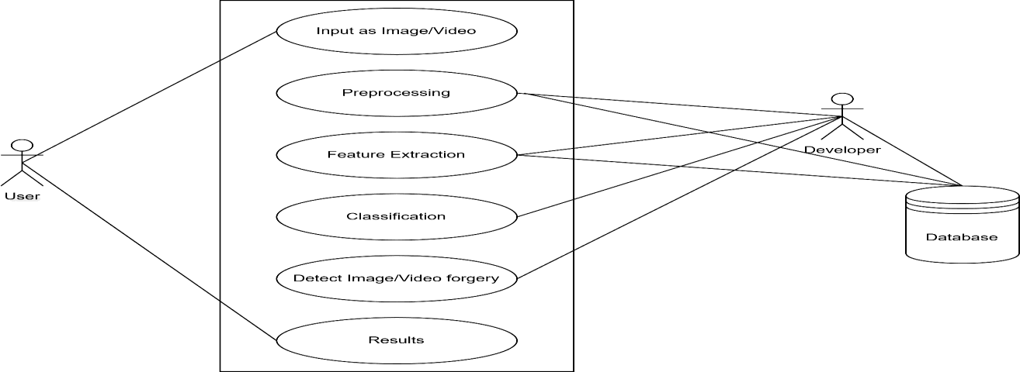

**Fig. 3.1:** Use Case Diagram

The above image is a use case diagram that illustrates how a user and a developer interact with an image/video forgery detection system. The user uploads media, which passes through several stages including preprocessing, feature extraction, classification, and forgery detection, before producing results. Meanwhile, the developer manages the internal processes and interacts with the database.

#### Sequence Diagram

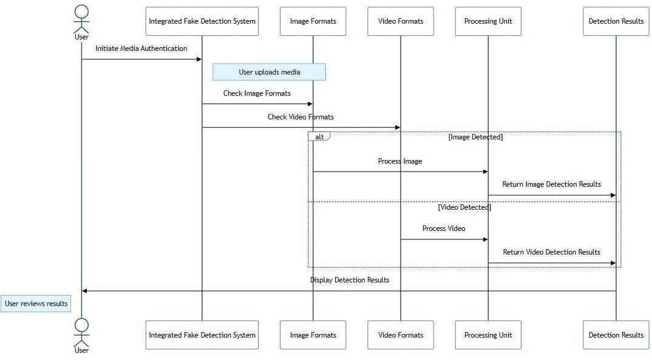

**Fig. 3.2:** Sequence Diagram

The above image is a sequence diagram showing how a user uploads media to the system, which checks the format (image or video), processes it accordingly, and returns detection results to the user. It outlines the real-time interaction between system components.

#### Activity Diagram

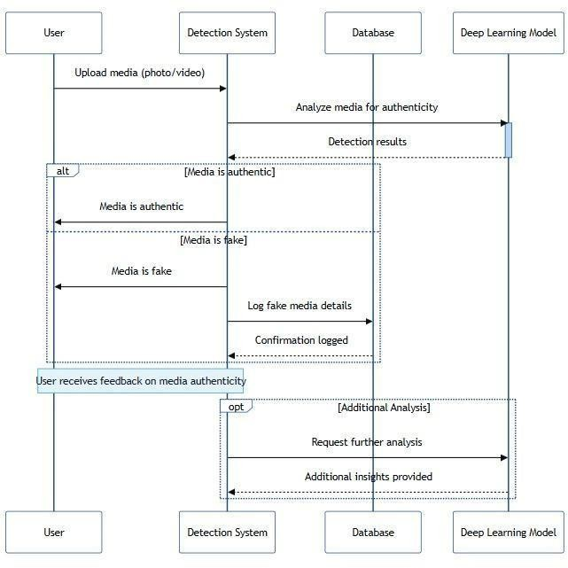

**Fig. 3.3:** Activity Diagram

The above image is another sequence diagram that goes deeper into the detection process. It shows how uploaded media is analyzed using a deep learning model, determines whether it’s authentic or fake, logs the results, and allows users to optionally request further analysis for additional insights.

#### State Diagram

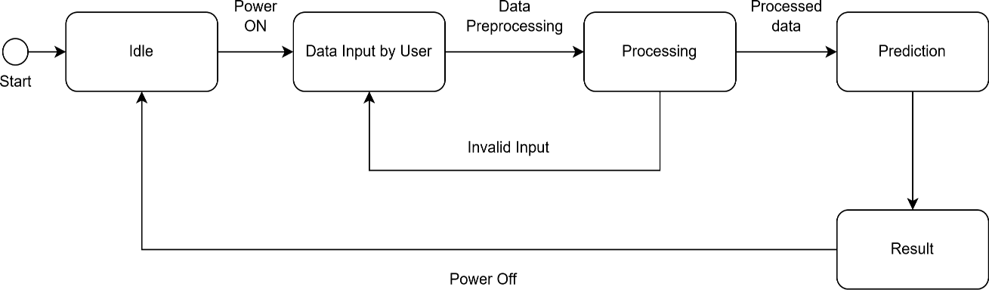

**Fig. 3.4:** State Diagram

This state diagram represents the operational flow of a media authentication system. It begins in the Idle state when powered on. The user then inputs data, which moves the system to preprocessing. If the input is invalid, the system loops back to Idle. Otherwise, the system processes the data and forwards the results for prediction. The prediction results are then delivered as output. After the result is shown, the system transitions back to Idle or turns off, completing the process cycle.

#### Class Diagram

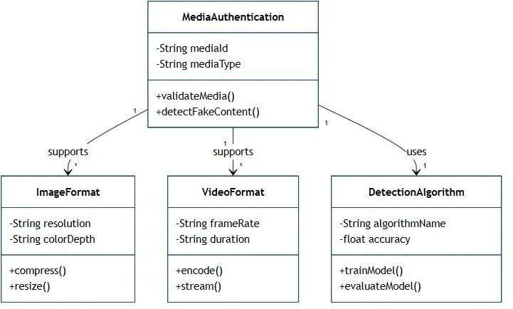

**Fig. 3.5** Class Diagram

The class diagram models the structure of a media authentication system. The central class, MediaAuthentication, holds attributes like mediaId and mediaType and includes methods for validating media and detecting fake content. It supports associations with

ImageFormat and VideoFormat classes, which define image and video-specific properties such as resolution, color depth, frame rate, and duration. These classes also provide functions for compression, encoding, and streaming. Additionally, the MediaAuthentication class uses a DetectionAlgorithm class, which includes methods for training and evaluating the detection model, indicating a modular design for media forgery detection.

### Software Requirements Specifications

#### User Requirements:

* **Accurate Detection:** The system must reliably identify fake or manipulated content across text, image, video, and audio formats.
* **Real-time Processing:** Users should receive prompt feedback, especially for social media or live content monitoring.
* **User-friendly Interface:** The platform should offer a simple, intuitive interface for uploading, analyzing, and viewing results.
* **Multi-format Support:** It should accept various file types (e.g., .jpg, .mp4, .mp3, .txt) for comprehensive analysis.
* **Explainability:** The system should provide understandable explanations or visual cues on why content was flagged as fake.
* **Security and Privacy:** User data and uploaded content must be handled securely and confidentially.
* **Scalability:** The system should support a large number of users and content items without performance loss.
* **Update Mechanism:** The model should be updatable to adapt to new types of manipulations or fake content trends.

#### System Requirements:

* **Media Processing:** It should handle diverse media formats (image, video, audio, text) for analysis and validation.
* **Deep Learning Models:** Incorporate models capable of detecting forgery and manipulation across multiple content types.
* **Cloud Integration:** Enable cloud-based storage and remote access for scalability and centralized processing.
* **Real-time Feedback:** Provide immediate analysis results and alerts when fake or altered content is detected.

# Chapter 4 Project Planning

### Chapter 4

## Project Planning

**Fig. 4.1:** Project Planning

**Major Project Phase I Timeline (Q1–Q2 2025)**

This report outlines the planned and ongoing activities for the Major Project scheduled across February to May 2025. The project is broken down into key milestones and activities, as illustrated in the Gantt chart.

**Project Synopsis Submission**

* Duration: Early February to early March 2025
* Status: Completed (marked with a green checkbox)
* Description: The initial phase involved preparing and submitting the project synopsis. This formed the foundation for subsequent phases and included problem identification, objectives setting, and scope definition.

**Conduction of Literature Survey**

* Duration: Mid-February to mid-March 2025
* Status: Completed
* Description: A comprehensive literature survey was conducted to review existing research, methodologies, and technologies relevant to the project. This phase ensured a strong theoretical foundation and helped refine the project scope.

**Primary Presentation Preparation**

* Duration: Mid-March to end of March 2025
* Status: Completed
* Description: Preparation for the initial project presentation, including documentation, slides, and gathering data insights.

**Primary Presentation**

* Date: End of March 2025 (one-day event)
* Status: Completed
* Description: The first formal presentation of the project’s progress. Feedback and suggestions received during this presentation were used to refine and steer the upcoming phases.

**Review and Interaction with Guide**

* Duration: Early April to mid-April 2025
* Status: In Progress
* Description: Ongoing consultation and feedback sessions with the project guide. This phase aims to validate the current direction of the project, address issues, and improve implementation plans.

**Final Project Presentation (Phase I)**

* Duration: Mid-April to end of April 2025
* Status: Pending
* Description: The final presentation for Phase I of the project, where the results of initial work, methodologies used, and plans for Phase II will be reviewed. This is a key evaluative milestone before progressing further.

The Gantt chart shows that the project is progressing according to schedule, with early tasks completed and the current focus on guide review and finalizing Phase I. The clear structure of this timeline facilitates effective planning, progress tracking, and timely completion of the major project objectives.

# Chapter 5 Applications and Conclusion

**Chapter 5**

## APPLICATIONS AND CONCLUSION

### Applications

* + - **Social Media Monitoring**: Detect and flag manipulated or AI-generated images and videos on platforms like Facebook, Twitter, and Instagram to prevent the spread of misinformation and maintain platform integrity.
    - **Digital Forensics**: Assist law enforcement and forensic investigators in authenticating image and video evidence by identifying tampered or synthetically altered media.
    - **News and Journalism**: Validate the authenticity of media content used in news articles and broadcasts, helping prevent the dissemination of fake news and maintaining journalistic credibility.
    - **Biometric Security**: Improve the robustness of facial recognition systems by detecting spoofing attacks and deepfakes, enhancing identity verification and access control.
    - **Legal Evidence Verification**: Ensure the authenticity of visual evidence presented in courts or legal proceedings, supporting justice and fair trials through reliable media authentication.
    - **E-commerce Fraud Detection**: Identify counterfeit product images and manipulated promotional content used in online scams or deceptive advertisements to protect consumers and businesses.
    - **Political and Electoral Integrity**: Detect deepfake videos or manipulated content targeting political leaders or parties, helping uphold election transparency and prevent voter manipulation.
    - **Healthcare and Telemedicine**: Authenticate medical images and videos used for diagnosis or teleconsultation to prevent tampering and ensure accurate treatment decisions.
    - **Content Moderation**: Automatically detect and filter harmful or fake content such as AI-generated pornography, violence, or misinformation on content-sharing and streaming platforms.
    - **Public Awareness and Education**: Empower users and educators with tools to detect fake content, raise awareness about deepfakes, and promote responsible digital citizenship.

The applications of deep learning for media authentication and fake content detection are vital in today’s digital world where manipulated content spreads rapidly and can influence public opinion, legal outcomes, and brand trust. By leveraging advanced deep learning models,

organizations can automatically analyse and verify the authenticity of images and videos, detect tampering patterns, and flag suspicious content. This capability is critical for industries like journalism, law enforcement, healthcare, and e-commerce, where trust in digital media is paramount. For example, in journalism, detecting deepfakes ensures accurate reporting, while in biometric security, it protects systems from spoofing attempts. Ultimately, this technology strengthens content authenticity, enhances security, and fosters digital trust across various sectors.

### Conclusion

The deep learning-based system for media authentication and fake content detection demonstrates a robust and scalable solution for combating the growing threat of digital media manipulation. By utilizing techniques such as convolutional neural networks and generative adversarial network (GAN) detectors, the system can effectively identify tampered images and deepfake videos. This capability plays a crucial role in protecting public trust, ensuring legal and journalistic integrity, and enhancing digital security. The system addresses challenges like detecting high-quality manipulations and generalizing across different datasets, offering reliable performance in real-world scenarios. Its versatility enables applications in social media monitoring, forensic investigations, and biometric authentication, making it a valuable tool for multiple industries. Overall, this project showcases the transformative potential of artificial intelligence in safeguarding digital content, empowering stakeholders with the means to verify authenticity, and contributing to a more secure and trustworthy digital ecosystem.

# References

## REFERENCES

1. N. Al Shariah and A. K. Saudagar, “Detecting Fake Images on Instagram Using Machine Learning,” *IEEE*, 2021.
2. M. S. Rana, M. N. Nobi, B. Murali, and A. H. Sung, “Deepfake Detection: A Systematic Literature Review,” *IEEE*, 2022.
3. V. V. Reddy, P. Priyanka, D. K. Supriya, P. R. Vishnu, A. D. Kumar, and S. B. Gole, “Fake Image Detection Using Machine Learning,” *International Journal of Advanced Research in Computer and Communication Engineering (IJARCCE)*, 2022.
4. Malik, M. Kuribayashi, S. M. Abdullahi, and A. N. Khan, “DeepFake Detection for Human Face Images and Videos: A Survey,” *IEEE Access*, vol. 10, pp. 18757–18785, 2022, doi: 10.1109/ACCESS.2022.3151186.
5. P. Edwards, J.-C. Nebel, D. Greenhill, and X. Liang, “A Review of Deepfake Techniques: Architecture, Detection, and Datasets,” *IEEE*, 2023.
6. R. S. Khudeyer and N. M. Al-Moosawi, “Fake Image Detection Using Deep Learning,”

*Informatica*, 2023.

1. S. B. Boddu, A. V. Kanumuri, and D. T. C. Ravipudi, “Fake Images Detection: A Comparative Study Using CNN and VGG-16 Models,” *IEEE Access*, 2023.
2. M. M. El-Gayar, M. Abouhawwash, S. S. Askar, and S. Sweidan, “A Novel Approach for Detecting Deep Fake Videos Using Graph Neural Network,” *Journal of Big Data*, vol. 11, 2024, doi: 10.1186/s40537-024-00884-y.
3. N. Rathoure, R. K. Pateriya, N. Bharot, and P. Verma, “Combating Deepfakes: A Comprehensive Multilayer Deepfake Video Detection Framework,” *Multimedia Tools and Applications*, vol. 83, 2024, doi: 10.1007/s11042-024-20012-5.
4. A Kaur, A. N. Hoshyar, V. Saikrishna, S. Firmin, and F. Xia, “Deepfake Video Detection: Challenges and Opportunities,” *Artificial Intelligence Review*, vol. 57, pp. 159– 204, 2024, doi: 10.1007/s10462-024-10810-6.